**Specification Document-**

**RFID Tag Reader and Fingerprint Reader**

**-:Mentor:-**

Avichal Gupta

**-:Team:-**

Kaushik Patil

Sambit Prabhu

Harshwardhan Raghu

Abhijith Reddy Dasari

Devansh Kumar

**What is RFID?**

RFID (Radio Frequency Identification) is a non-contact, automatic identification technology that uses radio signals to identify, track, sort, and detect a variety of objects, including people, vehicles, goods, and assets without the need for direct contact or line-of-sight contact (as found necessary in bar code technology). RFID technology can track the movement of objects through a network of radio-enabled scanning devices over a distance of several meters. A device called an RFID tag, or simply a tag, is a vital component of the technology. These are actively used in RFID-based access control systems implemented in offices all around.

**Problem Description**

Security is a big concern for people all over the world. But modern electronic security systems are costly, which prevents the majority of people from buying it. People tend to purchase those products that fulfill their needs and are reasonably priced. But there are very few affordable electronic security solutions in the market for people to buy and make their homes and valuables secure.

**Objective**

To make a low-cost, affordable, easy-to-use, dual security system using RFID Tag Reader and Fingerprint sensor.

**Components Required**

1. Servo Motor 2. Breadboard

 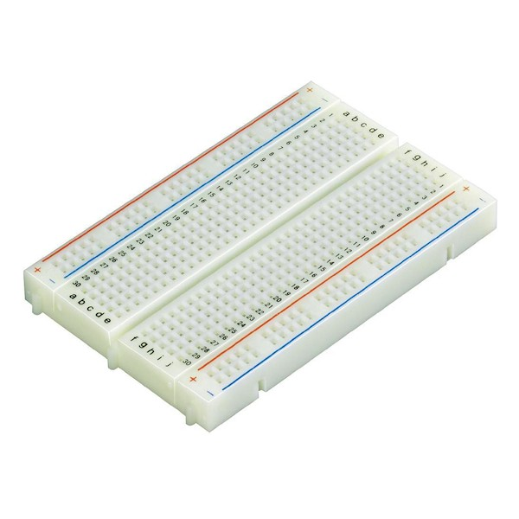

3. Arduino 4. Jumper cables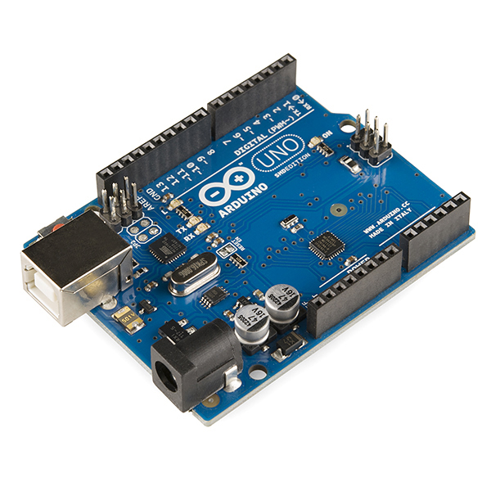 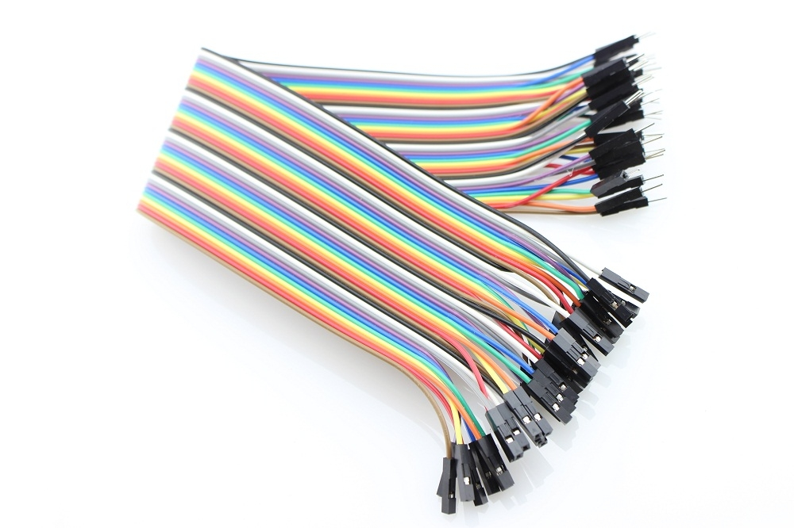

5. Fingerprint sensor 6. Buzzer

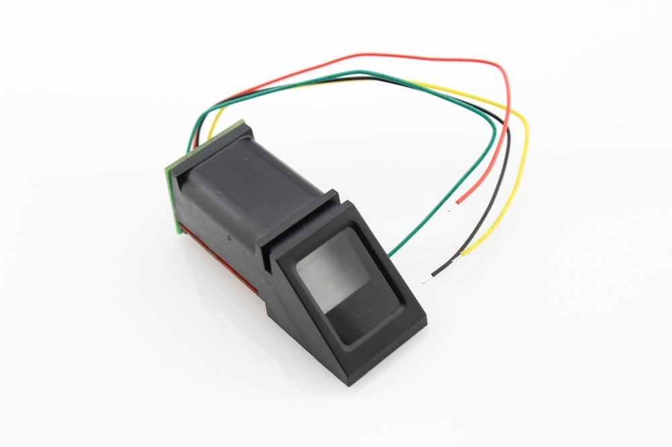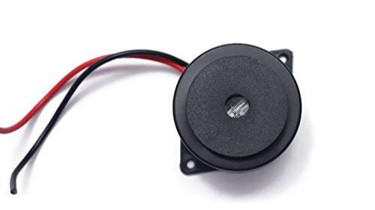

7. LED Bulbs 8. 16×2 LCD display 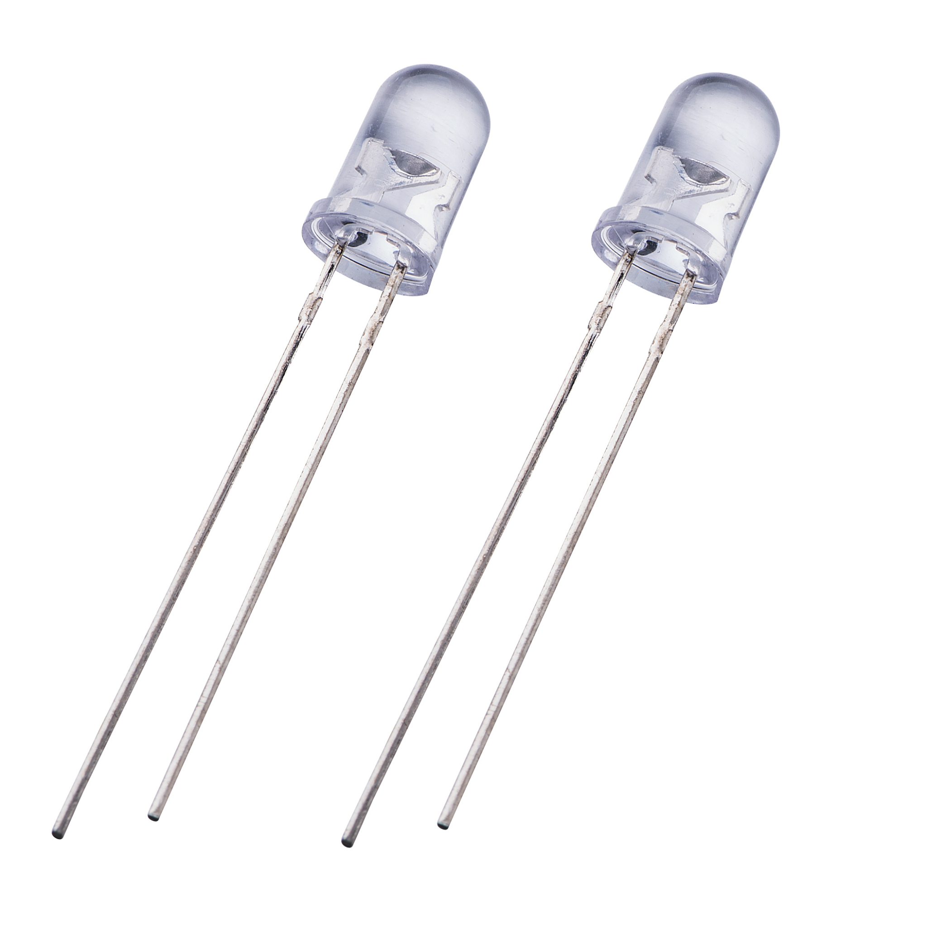 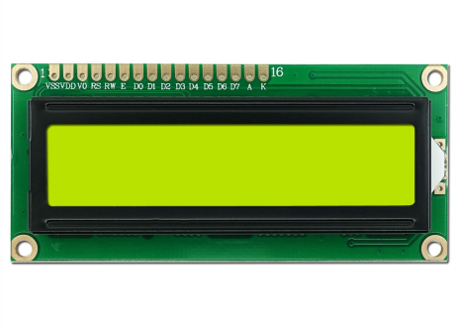

9. RFID Tag Reader, RFID tags

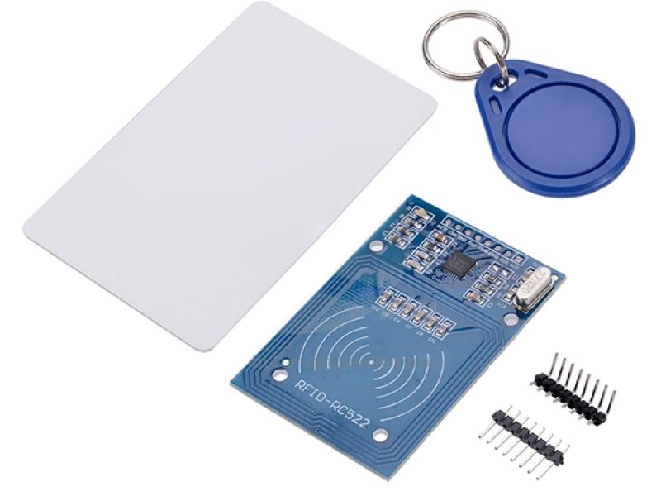

**Procedure**

1. Software simulation: -

The circuit simulation will be done on the Tinkercad circuit simulator.

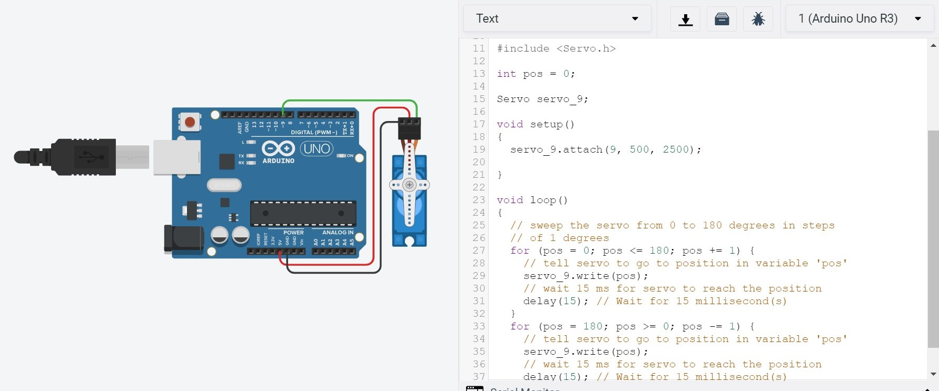

2. Hardware Assembly: -

The next step is assembling the hardware. Electrical connections will be made between the Arduino Uno module, breadboard, RFID sensor, and servo motor. We will attach the servo motor to a door lock which will be able to open the door after validating both the RFID Tag + Fingerprint. This will be achieved by connecting them using AND Gate. Also, we will use LED and Buzzer, which will operate when the sensor results are affirmative. After the affirmation from sensors, the servo motor comes into play and unlocks the door.

Circuit diagram example: -

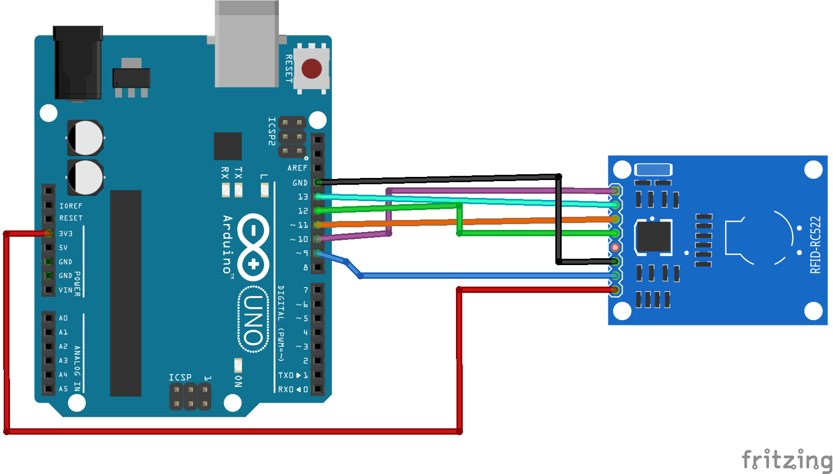

3. Integration:

The last step is to integrate the hardware and software. The Arduino module will be connected to a pc using a USB cable and then Arduino IDE will be used to upload the code to the module.

**Feasibility in online mode**

We believe that this project is feasible in the online mode because simulation software is available for Arduino hardware, and once the simulation is completed, assembling the hardware should be a relatively straightforward job for one person.

Thank You.